### **1. What is Maven? (Real-World Perspective)**

**Definition**: Maven is a build automation and dependency management tool primarily used for Java projects.

#### **Real-World Use Case:**

You're working on a **Banking Application** where multiple developers are contributing. Each module (like payments, loans, customer portal) needs specific Java libraries (e.g., Spring, Hibernate). Manually managing these libraries and building the application is error-prone.

**Maven helps:**

* Automatically downloads required libraries (dependencies) from a central location.
* Builds project consistently across environments.
* Packages the final application into .jar, .war, or .ear.

### **2. Maven Outputs (Artifacts)**

**Real-World Artifacts:**

* .jar → For libraries/utilities (e.g., currency converter module)
* .war → For deploying web apps to a server (e.g., customer web portal)
* .ear → For large-scale enterprise apps containing multiple modules (e.g., ERP)

### **3. Repository Types in Maven (Explained with Diagram)**

From your slide:

User’s Machine → Local Repository (1st preference)

→ Remote Repository (Organization network)

→ Central Repository (Internet - Maven Central)

#### **Real-World Scenario:**

Imagine you're at **TCS** working on a secured internal HR system. Due to firewall restrictions:

* Maven first checks if the dependency is in the **local repo** (~/.m2 folder).
* If not found, it checks the **internal remote repo** (e.g., Nexus/Artifactory).
* If not found even there, and if internet is allowed, it fetches from **Maven Central**.

### **4. Key Maven Commands and Usage**

#### **Compiling & Packaging Java Project**

mvn clean install

**Result**:

* Cleans previous builds.
* Compiles Java files.
* Packages the .war or .jar.
* Installs it into the **local repo** for reuse.

#### **Real-World Use:**

As a DevOps Engineer, you'd automate the build in Jenkins/GitHub Actions:

mvn test

mvn package

This ensures the code is built and tested before deployment.

### **5. Automation Using Chocolatey + Maven (From Notes)**

#### **Real-World Scenario:**

You're onboarding a new Windows developer. Instead of manual setup:

choco install maven

choco install java8

choco install git

Now they’re ready to clone the repo and build with Maven.

### **6. Git + Maven Workflow (From Notes)**

#### **Steps:**

1. git clone <project-url>
2. cd <project>
3. mvn clean package
4. Deploy the .war or .jar to test/production server.

#### **Real-World Workflow in a CI/CD Pipeline:**

1. **Pull** code from GitHub.
2. **Build** using Maven.
3. **Run Tests**.
4. **Generate Artifact**.
5. **Deploy** to a server using tools like Ansible, Docker, or Helm.

### **7. Dependency Resolution in Maven**

**Command**: mvn package

**Real-World Flow**:

1. Checks for dependencies in pom.xml.
2. Pulls from:  
   * **Local** (if already downloaded)
   * **Remote** (e.g., internal Nexus)
   * **Central** (if allowed)

### **8. Maven Install Command**

**Command**: mvn install

**Purpose**: Installs the compiled .jar into the **local repository** (~/.m2).

#### **Real-World Use:**

You created a custom Java library used by other internal projects. After mvn install, teammates can use it as a dependency in their pom.xml.

### **Summary Table**

| **Concept** | **Real-World Example** |
| --- | --- |
| mvn package | Build a deployable .war file for web app |
| Local Repo | Developer’s .m2 folder |
| Remote Repo | Nexus/Artifactory inside organization |
| Central Repo | Maven Central (Internet) |
| Chocolatey | Simplifies setup on Windows machines |
| Artifact | Final build (.jar, .war, .ear) deployed to test/prod |
| Automation | CI/CD pipelines: Git → Build → Test → Deploy |

Let me know if you want this as a formatted DOCX file or need CI/CD flow with Maven + Jenkins or GitHub Actions.

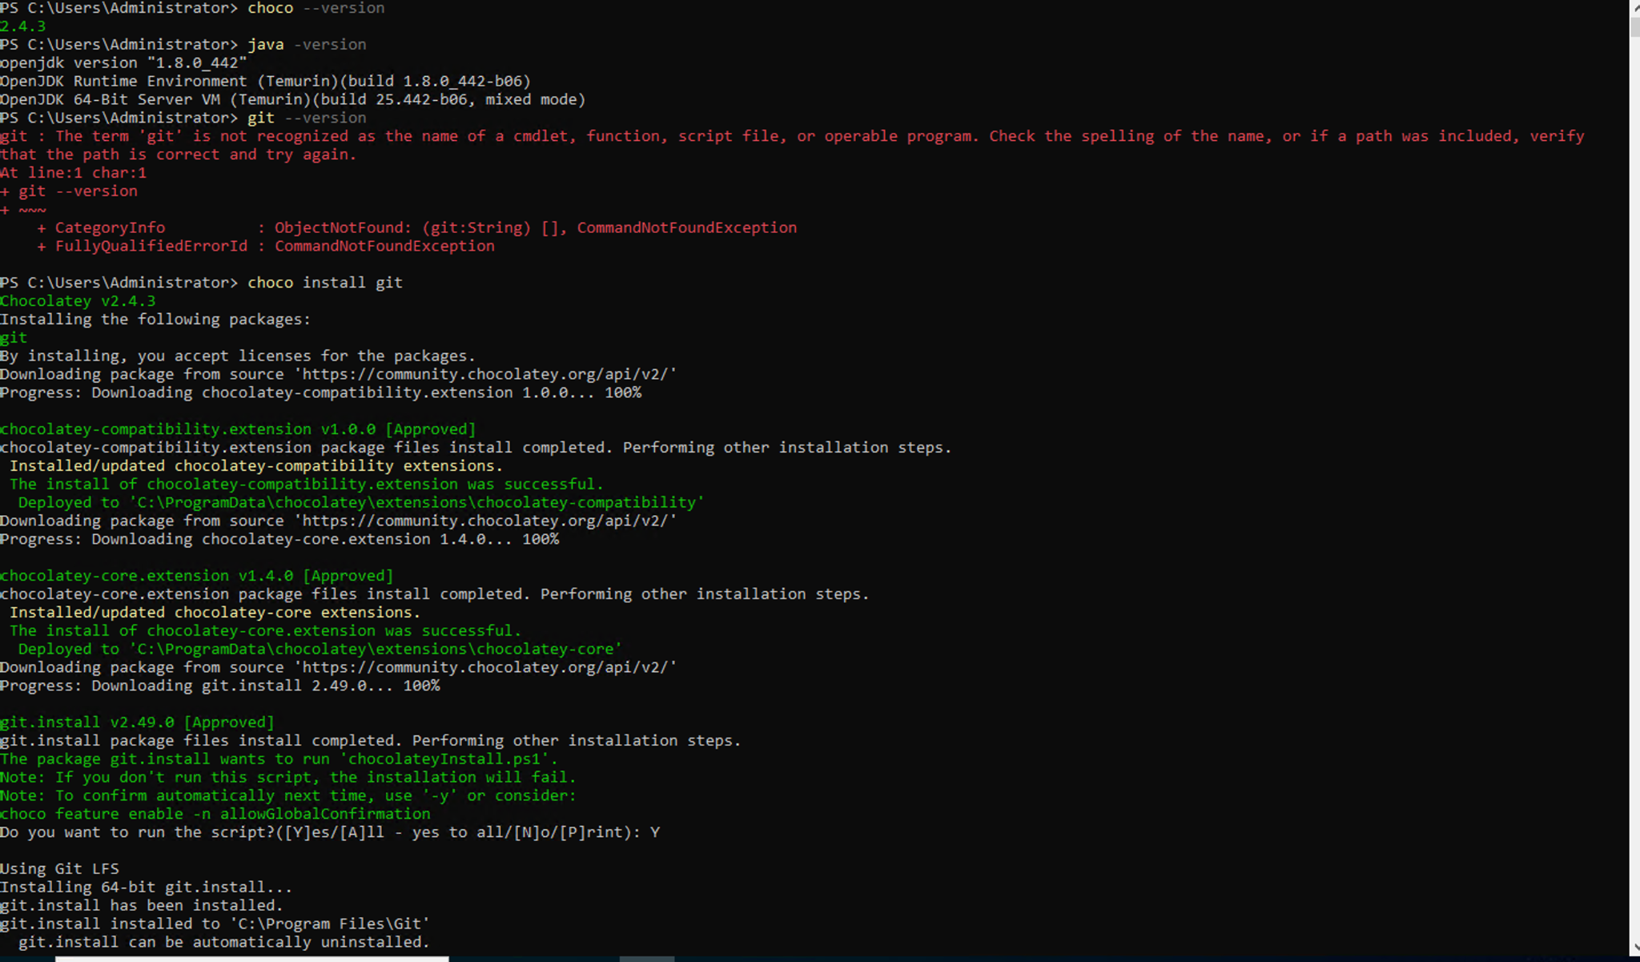

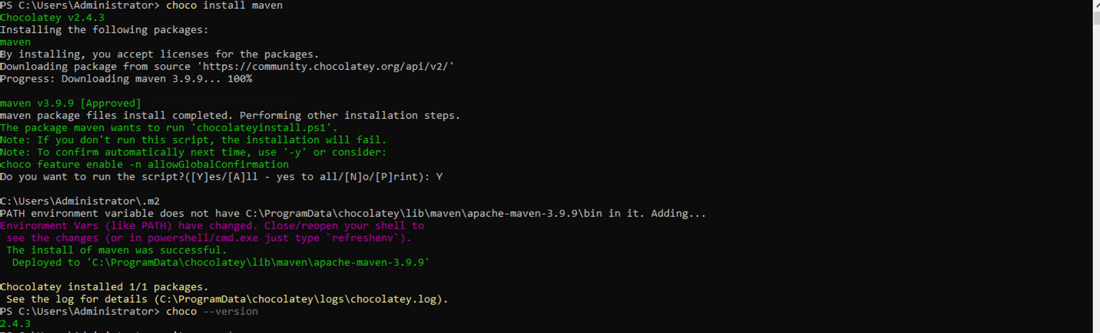

Repo Link:

<https://github.com/maha4dsvc/mahalogin>

<https://github.com/AbdulRehaman082493/mahalogin>

[mahalogin](https://github.com/AbdulRehaman082493/mahalogin)

Public

forked from [maha4dsvc/mahalogin](https://github.com/maha4dsvc/mahalogin)

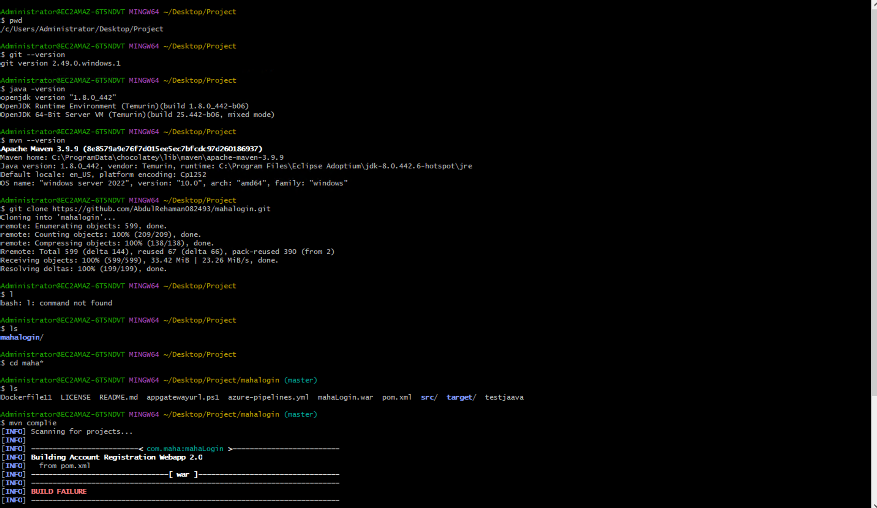

### **What It Does**

This Maven command performs two major actions:

1. **clean**: Deletes the target/ directory to remove any previous build artifacts.
2. **package**: Compiles the code, runs tests, and packages it into a deployable format (.jar, .war, or .ear) as defined in the pom.xml.

### **Real Folder Structure Before & After**

#### **Before:**

/myproject

├── src/

├── pom.xml

└── target/ ← might contain old builds

After Running:

mvn clean package

After:

/myproject

├── src/

├── pom.xml

└── target/

├── classes/

├── myproject-1.0.0.jar / .war / .ear

└── test-results/

### **Real-World Example**

You're building a **Java web application** for a college management system.

* Source code is in /src/main/java
* pom.xml defines dependencies and build type (war)

You run:

mvn clean package

Result:

* Deletes any previously compiled classes or build outputs.
* Recompiles the code.
* Packages it into target/college-portal-1.0.war.

You can now deploy this .war to **Apache Tomcat**, **WildFly**, or use it in a CI/CD pipeline.

When to Use

| **Use Case** | **Run mvn clean package?** |
| --- | --- |

| You want to generate a fresh .jar/.war | ✅ Yes |
| --- | --- |

| You changed source code | ✅ Yes |
| --- | --- |

| You want to deploy to staging/production | ✅ Yes |
| --- | --- |

| You just want to run tests | ❌ Use mvn test |
| --- | --- |

| You want to skip tests | ✅ Add -DskipTests |
| --- | --- |

mvn clean package -DskipTests

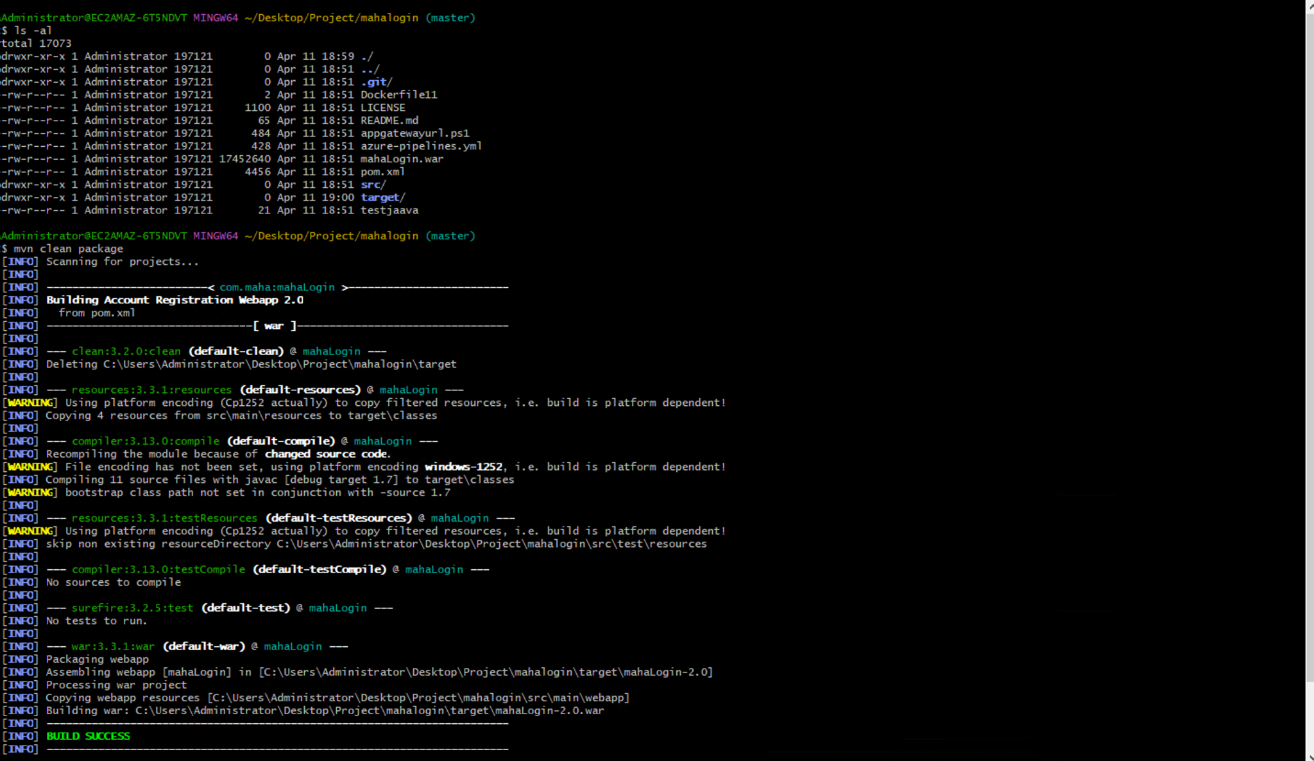

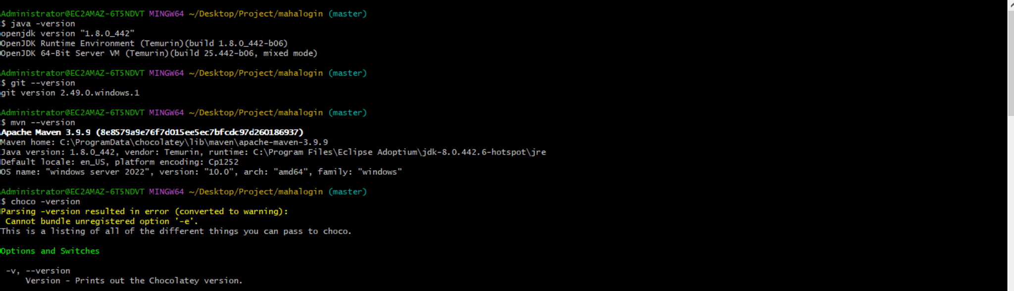

| **Command** | **Description** | **Real-World Use** |
| --- | --- | --- |

| mvn clean | Deletes the target/ directory (old builds) | Clean slate before new build |
| --- | --- | --- |

| mvn compile | Compiles the Java source code | Checks for compilation errors |
| --- | --- | --- |

| mvn test | Runs unit tests using JUnit/TestNG | Validates code logic |
| --- | --- | --- |

| mvn package | Creates .jar, .war, or .ear in target/ | Generates deployable artifact |
| --- | --- | --- |

| mvn install | Installs the artifact into the **local repo** (~/.m2) | Share artifact with other local projects |
| --- | --- | --- |

| mvn deploy | Pushes the built artifact to a **remote repo** (e.g., Nexus, Artifactory) | Share artifact with team/org |
| --- | --- | --- |

| mvn site | Generates documentation like reports, test coverage | For project analysis |
| --- | --- | --- |

### **Run a Specific Phase**

Maven uses a **build lifecycle**. These phases run in order:

mvn validate

mvn compile

mvn test

mvn package

mvn verify

mvn install

mvn deploy

You can run any one, and it executes all the ones before it.

Run with Flags/Options

| **Command** | **Description** |
| --- | --- |
| mvn package -DskipTests | Builds artifact but skips unit tests |
| mvn clean install -U | Forces update of snapshots from repo |
| mvn dependency:tree | Shows all project dependencies (like a tree) |
| mvn help:effective-pom | Displays final merged pom.xml with inherited values |

### **Archetype (Project Creation)**

| **Command** | **Description** |
| --- | --- |
| mvn archetype:generate | Starts interactive project generator |
| mvn archetype:generate -DgroupId=com.myapp -DartifactId=webapp -DarchetypeArtifactId=maven-archetype-webapp -DinteractiveMode=false | Creates a Maven web app project non-interactively |

Examples for DevOps/CI

# Build and test without tests

mvn clean install -DskipTests

# Generate WAR and push to remote repo

mvn clean deploy

# Display dependency hierarchy

mvn dependency:tree

# Run a specific test class

mvn -Dtest=MyTestClass test

Common Maven Lifecycle

mvn clean

mvn compile

mvn test

mvn package

mvn install

mvn deploy

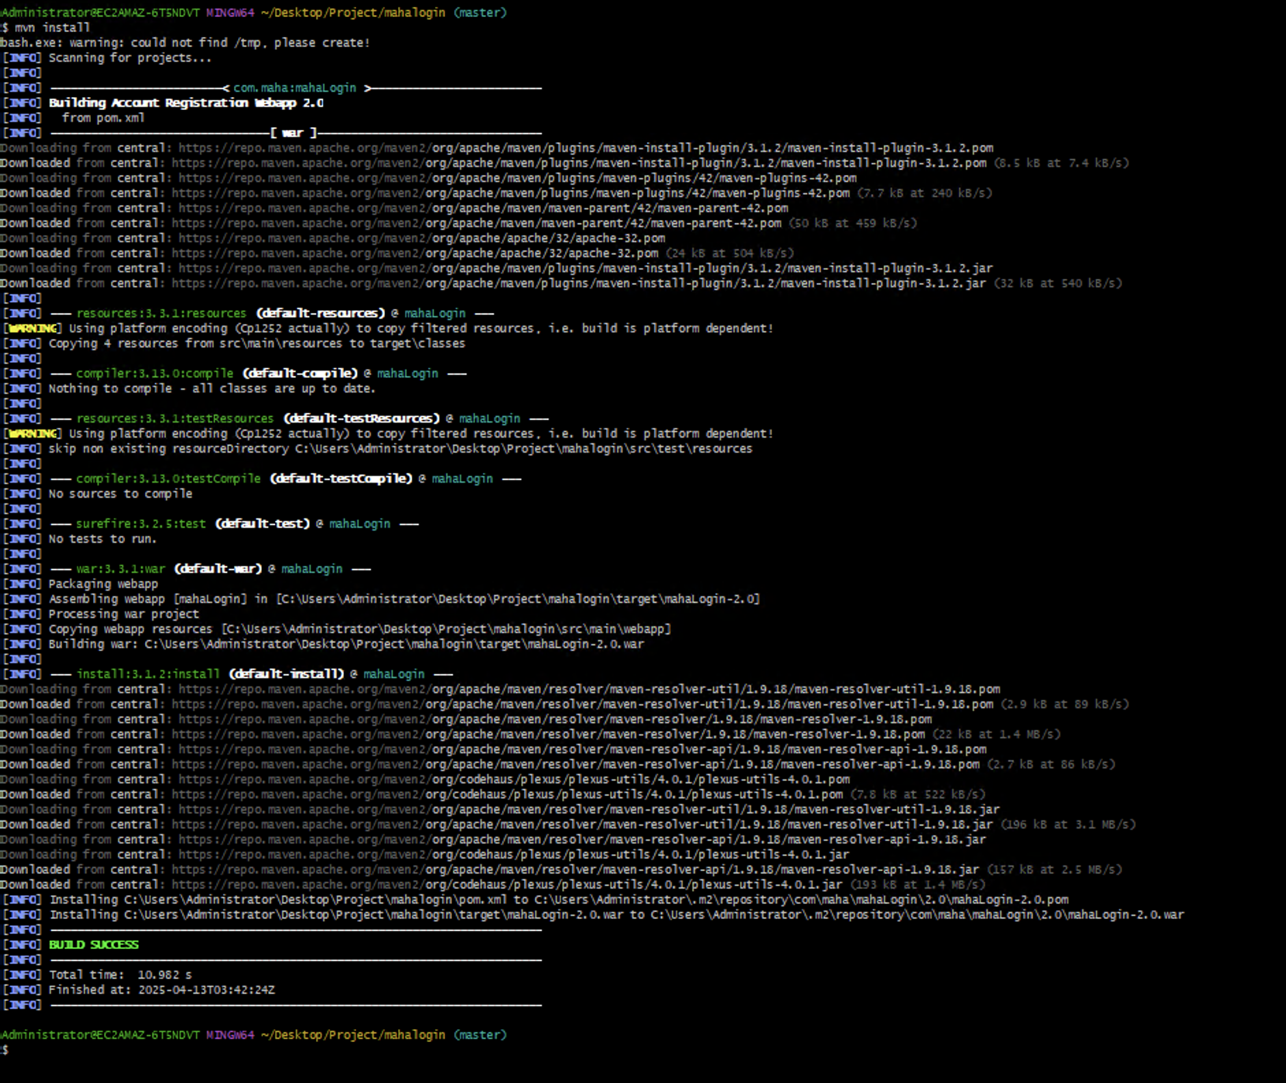

What Happened Step-by-Step

#### **1. Project Scanning**

Scanning for projects...

📌 Maven reads pom.xml to understand the project structure and dependencies.

#### **2. Build Phases Triggered (Lifecycle)**

Your command mvn install automatically ran all these phases:

| **Phase** | **Status** |
| --- | --- |

| validate | ✅ Check project structure |
| --- | --- |

| compile | ✅ Compile source code |
| --- | --- |

| test | ✅ Run unit tests (0 tests in your case) |
| --- | --- |

| package | ✅ Created mahaLogin-2.0.war |
| --- | --- |

| install | ✅ Installed .war in local repo |
| --- | --- |

Artifact Created

Building war: C:\Users\Administrator\Desktop\Project\mahaLogin\target\mahaLogin-2.0.war

A .war file is created from your src/main/webapp folder — this is deployable on servers like **Tomcat**.

**Installed to Local Repository**

Installed: C:\Users\Administrator\.m2\repository\com\maha\mahaLogin\2.0\mahaLogin-2.0.war

This means you can now reuse this war file as a dependency in other local Maven projects.

**Minor Log Warnings**

[WARNING] cmd: not found /tmp/_setup_pre.js create!

This is not a Maven issue — seems like a leftover from environment setup (ignore unless you use a custom shell script).

**Final Status**

[INFO] BUILD SUCCESS

Total time: 10.902 s

**Next Steps You Can Try**

| **Action** | **Command** |
| --- | --- |

| Deploy .war to Tomcat | Copy target/mahaLogin-2.0.war to webapps/ folder in Tomcat |
| --- | --- |

| Run on Jenkins/GitHub Actions | Use mvn clean install in pipeline |
| --- | --- |

| Share .war internally | Upload to Nexus/Artifactory using mvn deploy |
| --- | --- |

| Use in another Maven project | Add dependency in pom.xml with same groupId, artifactId, version |
| --- | --- |

Let me know if you'd like help with:

* **Creating a CI pipeline**
* **Deploying this .war to Tomcat or Azure**
* **Generating a Maven site report**
* **Understanding pom.xml content**

### **Command: mvn clean**

### **Purpose:**

Deletes the target/ directory created by a previous build.

### **Why it's used:**

* To **remove compiled .class files**, jars, and other build artifacts.
* Ensures the **next build starts fresh** without any old or cached data.
* Prevents issues due to **residual files** from previous builds.

### **Typical Use Case (Real World):**

Let’s say you’re developing a Java web app using Maven. You made code changes and built the project using mvn package. But something’s not working right in the deployed .war file.  
 You suspect some old compiled files are lingering. Running:

mvn clean package

will:

1. Remove everything inside the target/ folder.
2. Rebuild your application from scratch.
3. Generate a clean, new .war or .jar file without stale artifacts.

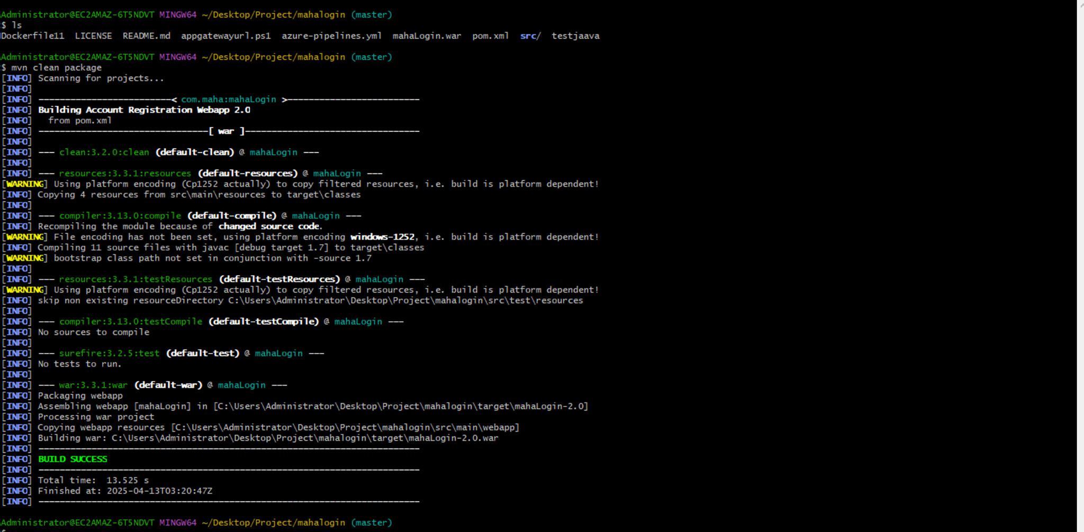

## **Maven Build Summary**

### **Command Run:**

mvn clean package

## **Project Info**

* **Project Name:** mahaLogin
* **WAR File:** mahaLogin-2.0.war
* **Final Output:** Located in  
   target/mahaLogin-2.0/mahaLogin-2.0.war

**Phases Breakdown**

| **Phase** | **Plugin & Goal** | **Action Taken** |
| --- | --- | --- |

| **clean** | **maven-clean-plugin:3.2.0:clean** | **Deleted previous target/ directory.** |
| --- | --- | --- |

| **resources** | **maven-resources-plugin:3.1.0:resources** | **Copied filtered resources to target/classes. Warning: using platform encoding Cp1252.** |
| --- | --- | --- |

| **compile** | **maven-compiler-plugin:3.13.0:compile** | **Compiled 11 Java source files targeting Java 1.7.** |
| --- | --- | --- |

| **testResources** | **maven-resources-plugin:3.1.0:testResources** | **Skipped: test resources directory does not exist.** |
| --- | --- | --- |

| **testCompile** | **maven-compiler-plugin:3.13.0:testCompile** | **Skipped: no test sources found.** |
| --- | --- | --- |

| **test** | **maven-surefire-plugin:3.2.5:test** | **Skipped: no tests to run.** |
| --- | --- | --- |

| **package** | **maven-war-plugin:3.3.1:war** | **Created .war file and copied resources from src/main/webapp.** |
| --- | --- | --- |

**Result**

BUILD SUCCESS

Total time: 13.525 s

## **Next Steps (if needed):**

* 🚀 Deploy the WAR to Tomcat, JBoss, or another servlet container.
* 🔍 Add test cases under src/test/java to enable test phases.
* ⚙️ Update pom.xml to set correct Java version if needed (currently using 1.7).

mvn compile

### **What It Does:**

* Compiles the project's **main source code** (src/main/java) into .class files.
* Outputs the compiled classes into the target/classes/ directory.

### **Maven Phase Triggered:**

* Invokes the **compile** phase of the Maven **build lifecycle**.
* Uses the **maven-compiler-plugin** internally.

### 

### 

### 

### 

### **Real Project Folder Example:**

Let’s say your project has:

src/

main/

java/

com/

example/

App.java

After running:

bash

CopyEdit

mvn compile

You’ll get:

swift

CopyEdit

target/classes/com/example/App.class

### **Real-World Scenario:**

You're working on a Java backend service and just updated some business logic in UserService.java.  
 To **test locally**, you want to compile the updated classes without creating a full .jar or .war.

Run:

mvn compile

This quickly checks for:

* **Syntax errors**
* **Missing imports**
* **Type mismatches**

...before you move on to packaging or deploying.

### **Bonus Tips:**

* To compile **and package**, use:

mvn clean package

To **recompile everything** from scratch:

mvn clean compile

Want to see what the maven-compiler-plugin settings look like in pom.xml?

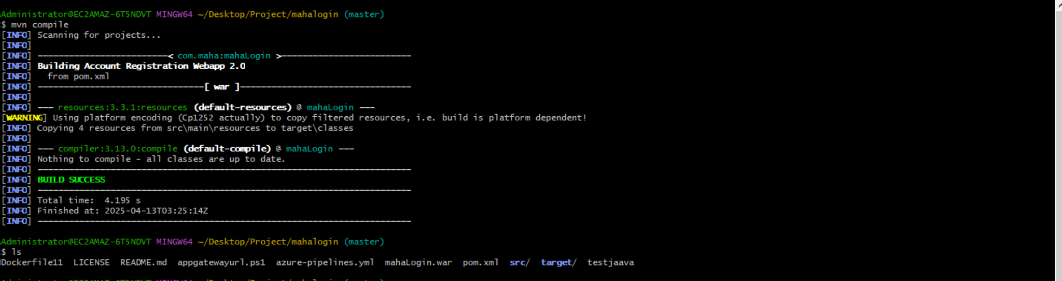

Perfect — based on your latest screenshot, here’s what the output of mvn compile indicates:

### **mvn compile – Successful Build (No Recompilation Needed)**

### **🔍 What Happened:**

* Maven scanned your project and found it was **already compiled**.
* It skipped Java file compilation because **no changes were made** since the last successful build.

### **Detailed Log Explanation:**

| **Step** | **Plugin** | **Action** |
| --- | --- | --- |
| resources:resources | maven-resources-plugin | Copied 4 resource files from src/main/resources to target/classes. |
| compiler:compile | maven-compiler-plugin | ✅ **"Nothing to compile - all classes are up to date."** |

This means your .java files in src/main/java haven't changed since your last mvn clean package.

If you want to **force recompilation**, run:

mvn clean compile

That will delete the target/ directory and freshly compile everything.

Let me know if you want to try a code change and recompile to see it in action.

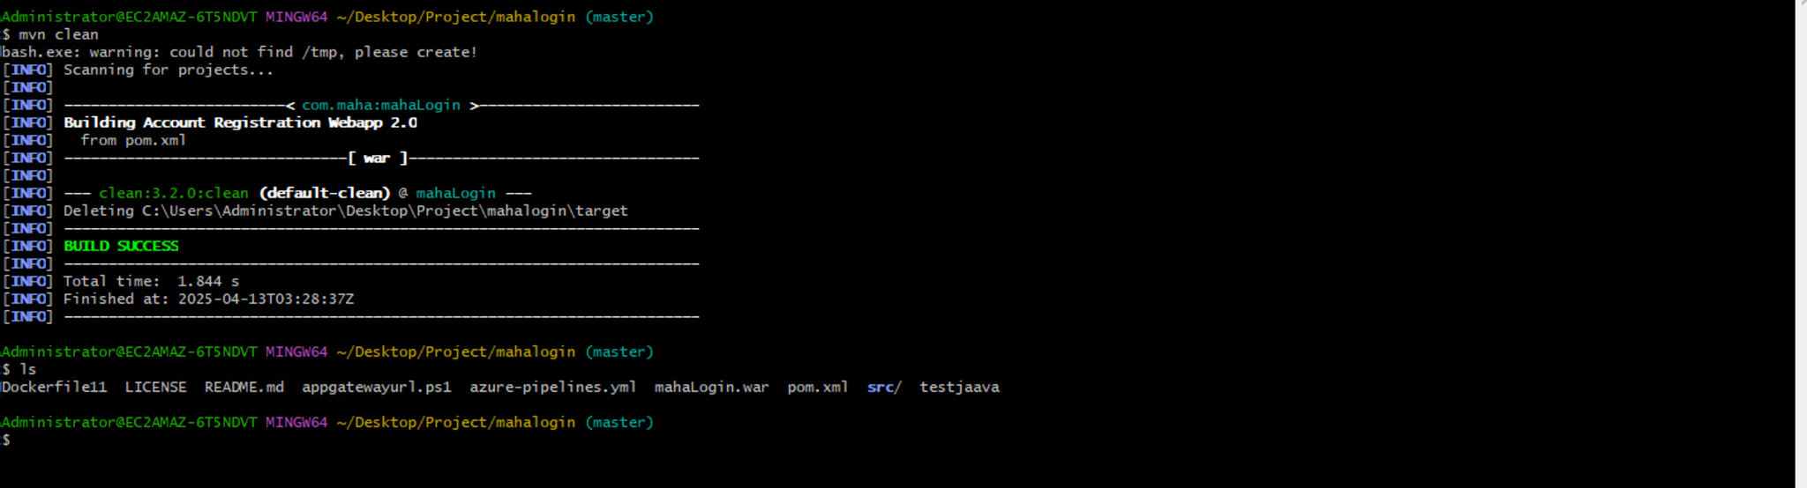

Awesome — in this last screenshot, the command mvn clean worked as expected. Here's a quick analysis:

### 

### **mvn clean – Executed Successfully**

### **🔧 What It Did:**

**Deleted** the target/ directory:  
  
 mathematica  
  
Deleting C:\Users\Administrator\Desktop\Project\mahalogin\target

* Resulted in a **clean slate** for your next build.

Displayed:  
  
 nginx  
  
BUILD SUCCESS

### **Notable Warning:**

lua

bash.exe: warning: could not find /tmp, please create!

This warning is harmless for Maven but can be fixed by:

* Creating a /tmp directory for Git Bash to avoid future warnings:  
    
   bash  
    
  mkdir /tmp

### 

### 

### **Why This Matters:**

Now, when you run:

bash

mvn compile

or

bash

mvn package

it will **rebuild everything from scratch**, ensuring no old artifacts mess up the process.

Let me know if you'd like to do a mvn package next to verify everything rebuilds properly.

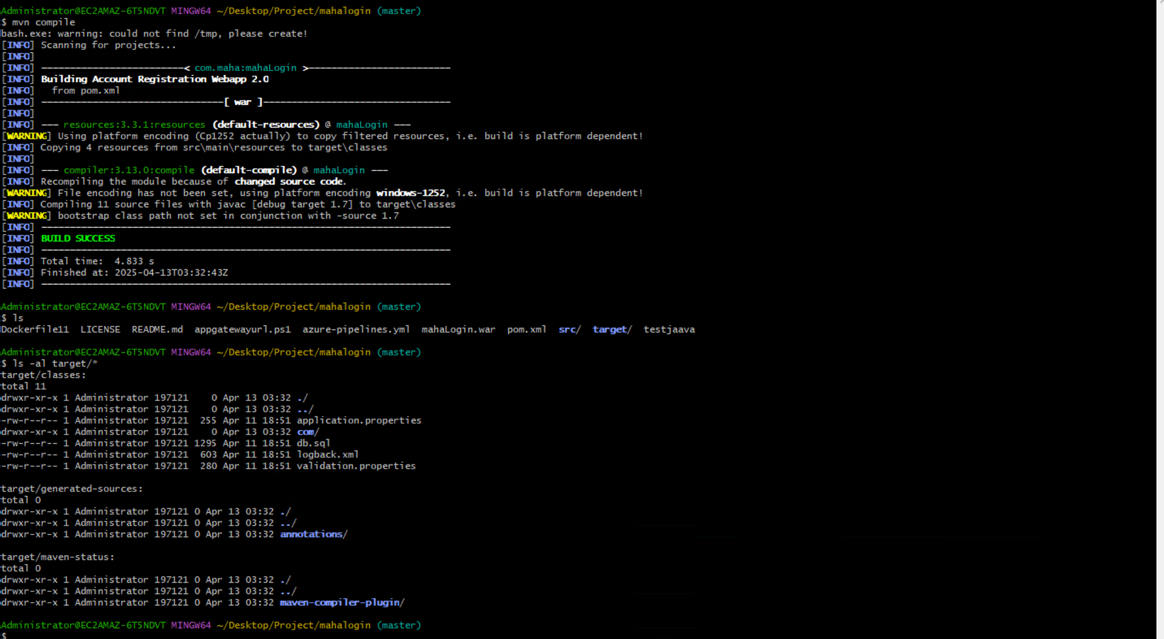

Perfect — this confirms that the mvn compile step ran successfully **after mvn clean**, and everything was freshly rebuilt.

## **✅ mvn compile Summary (Based on Screenshot)**

### **🔧 Key Actions:**

| **Step** | **Description** |
| --- | --- |

| **Resource Copy** | Copied 4 resources from src/main/resources → target/classes. |
| --- | --- |

| **Compilation** | Compiled 11 Java source files using javac targeting version 1.7. |
| --- | --- |

| **Output** | Compiled classes and resources are now in target/classes. |
| --- | --- |

## **target/classes/ Contents:**

| **Type** | **Name** | **Notes** |
| --- | --- | --- |
| *.class | In com/ | Your compiled Java classes. |
| .properties | application.properties, validation.properties | Copied from resources. |
| .sql | db.sql | Likely a schema/data file used at runtime. |
| .xml | logback.xml | Logging config (likely Logback for SLF4J). |

## **Other Target Subdirectories:**

* target/generated-sources/annotations/: Auto-generated files (e.g., for JPA, Lombok, etc.).
* target/maven-status/maven-compiler-plugin/: Status metadata for build tracking.

### **tatus:**

nginx

CopyEdit

BUILD SUCCESS

Everything looks good! You're now ready to:

* Run tests with mvn test (if any).
* Build deployable artifact using mvn package.

Would you like to:

1. **Run mvn package now**, or
2. **Explore the output WAR file structure** after packaging?

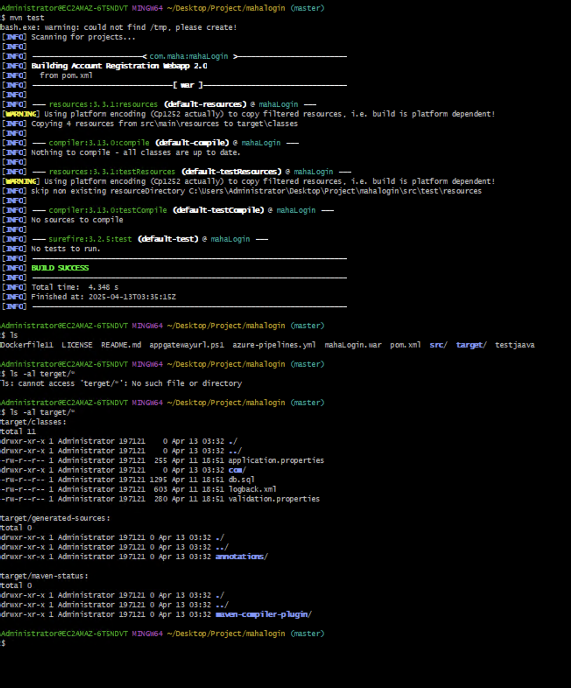

Great! You've successfully run:

bash

mvn test

Here’s the breakdown of what happened:

## **mvn test – Test Phase Summary**

### **🔍 Key Observations:**

| **Phase** | **Action** |
| --- | --- |
| resources:testResources | Looked for test resource files in src/test/resources, but none existed. |
| compiler:testCompile | No test source files to compile. |
| surefire:test | No unit tests found or executed. |
| **Result** | ✅ **BUILD SUCCESS** – clean test run with no errors or failures. |

## **Current target/ Directory Contents:**

You've listed the directory with:

bash

ls -al target/

### **Existing Folders:**

* classes/ – Contains compiled main classes and resource files.
* generated-sources/annotations/ – Placeholder for any annotation processors (like Lombok).
* maven-status/maven-compiler-plugin/ – Metadata for Maven’s internal state tracking.

### **✅ All folders were generated correctly during the build.**

## **Why No Tests Were Run?**

Because:

* No .java test files in src/test/java.
* No test classes with JUnit/TestNG annotations.

## **Next Steps You Can Try:**

**Create a test class** in src/test/java/com/maha/:  
  
 java  
  
package com.maha;

import org.junit.jupiter.api.Test;

import static org.junit.jupiter.api.Assertions.*;

public class SampleTest {

@Test

void testAddition() {

assertEquals(2, 1 + 1);

}

}

1. Then run:  
     
    bash  
     
   mvn test

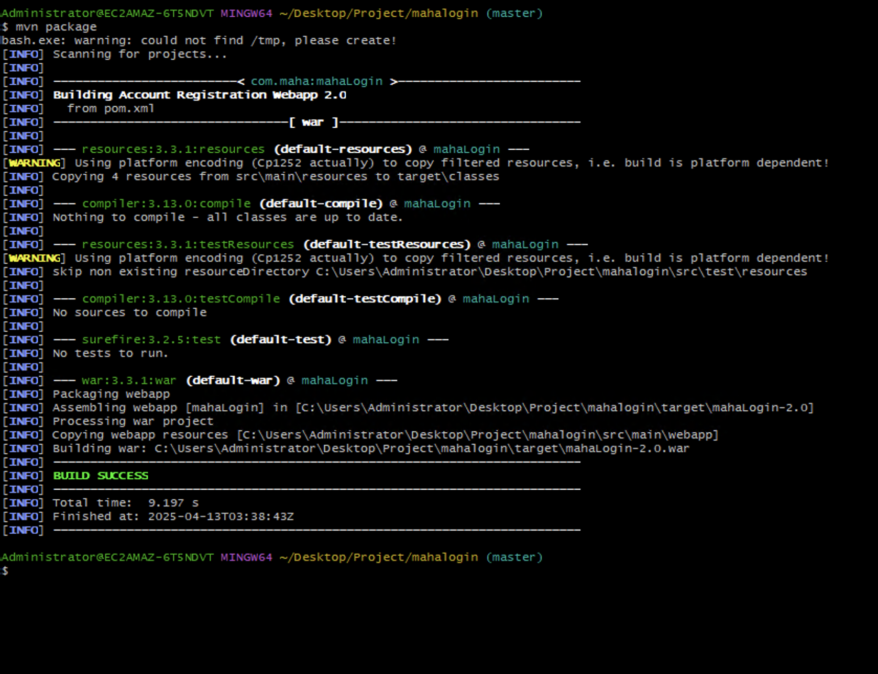

## **mvn package – Build Success & WAR Creation**

### **🧾 What Happened:**

| **Phase** | **Status** | **Details** |
| --- | --- | --- |
| resources:resources | ✅ | 4 resources copied to target/classes. |
| compiler:compile | ✅ | Skipped, no changes since last compile. |
| resources:testResources | ✅ | Skipped, test resources folder doesn't exist. |
| compiler:testCompile | ✅ | No test source files to compile. |
| surefire:test | ✅ | No tests to run. |
| war:war | ✅ | **WAR file created:**  target/mahaLogin-2.0.war |

**WAR File Location:**

bash

CopyEdit

C:\Users\Administrator\Desktop\Project\mahalogin\target\mahaLogin-2.0.war

This .war file is ready to be deployed to a servlet container like **Apache Tomcat**, **JBoss**, or **Jetty**.

### **Build Outcome:**

css

CopyEdit

BUILD SUCCESS

Total time: 9.197 s

## **Next Steps (Optional):**

* **Deploy to Tomcat:** Copy mahaLogin-2.0.war to the webapps/ folder of your Tomcat server and restart it.

**Explore WAR Contents (optional):** Run:  
  
 bash  
  
jar tf target/mahaLogin-2.0.war

* to view its structure.



Awesome! You've just run:

bash

mvn install

### **✅ Here's the Full Breakdown of What Happened:**

### **🔧 Phase: install**

This command does everything that package does **plus**:

📦 **Installs the built .war artifact into your local Maven repository** (~/.m2/repository)  
 So you (or other Maven modules) can reuse it **without re-downloading or rebuilding**.

| **Step** | **Plugin/Phase** | **Status** | **Description** |
| --- | --- | --- | --- |

| validate, compile, test, package | ✅ | Reused cached builds (no changes). |  |
| --- | --- | --- | --- |

| war:war | ✅ | Built the WAR: target/mahaLogin-2.0.war |  |
| --- | --- | --- | --- |

| **install:install** | ✅ | Copied WAR to: |  |
| --- | --- | --- | --- |

| C:\Users\Administrator\.m2\repository\com\maha\mahaLogin\2.0\mahaLogin-2.0.war |
| --- |

### **Installed Artifact Location:**

bash

~/.m2/repository/com/maha/mahaLogin/2.0/mahaLogin-2.0.war

This WAR can now be referenced from any Maven project using:

xml

CopyEdit

<dependency>

<groupId>com.maha</groupId>

<artifactId>mahaLogin</artifactId>

<version>2.0</version>

<type>war</type>

</dependency>

### **Final Result:**

css

BUILD SUCCESS

Total time: 10.982 s

## **Next Steps (optional):**

* ✔️ Deploy WAR to server
* 🔄 Create another Maven module and add this WAR as a dependency
* 🔍 Inspect local .m2 to verify it was installed correctly

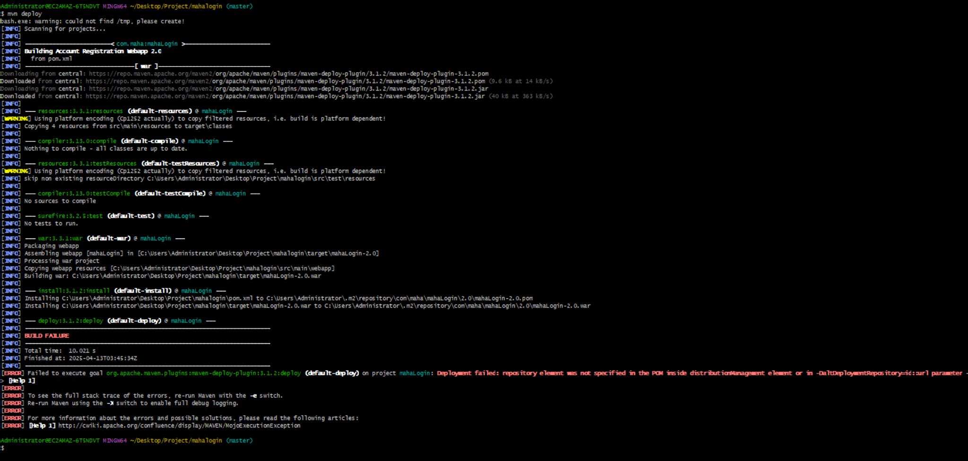

**Thanks for sharing the screenshot — you ran:**

**bash**

**mvn deploy**

**And you got this error:**

**❌ Deploy failed: repository element was not specified in the POM inside distributionManagement element or in -DaltDeploymentRepository=id::url**

## **Problem Explained**

**The mvn deploy goal is used to upload the built .war or .jar to a remote Maven repository (like Nexus, Artifactory, etc.).**

**But your pom.xml is missing the required distributionManagement section, so Maven doesn't know where to deploy.**

## **Fix: Add distributionManagement in pom.xml**

**Here's how to fix it:**

### **🔧 In your pom.xml, add:**

**xml**

**<distributionManagement>**

**<repository>**

**<id>my-repo</id>**

**<url>http://your-nexus-or-artifactory-server/repository/releases</url>**

**</repository>**

**</distributionManagement>**

**Replace the url with your actual remote repository URL (e.g., Nexus or Artifactory endpoint).**

## **lso Add Authentication (if needed)**

**In your Maven settings.xml (usually in ~/.m2/settings.xml), add:**

**xml**

**<servers>**

**<server>**

**<id>my-repo</id> <!-- This must match the <id> in your pom.xml -->**

**<username>your-username</username>**

**<password>your-password</password>**

**</server>**

**</servers>**

## **Alternative (Temporary) Deploy:**

**If you just want to deploy without modifying pom.xml, use the command line:**

**bash**

**mvn deploy:deploy-file \**

**-DgroupId=com.maha \**

**-DartifactId=mahaLogin \**

**-Dversion=2.0 \**

**-Dpackaging=war \**

**-Dfile=target/mahaLogin-2.0.war \**

**-DrepositoryId=my-repo \**

**-Durl=http://your-repo-url/repository/releases**

**Let me know if you want help setting this up for a real Nexus or Artifactory deployment.**

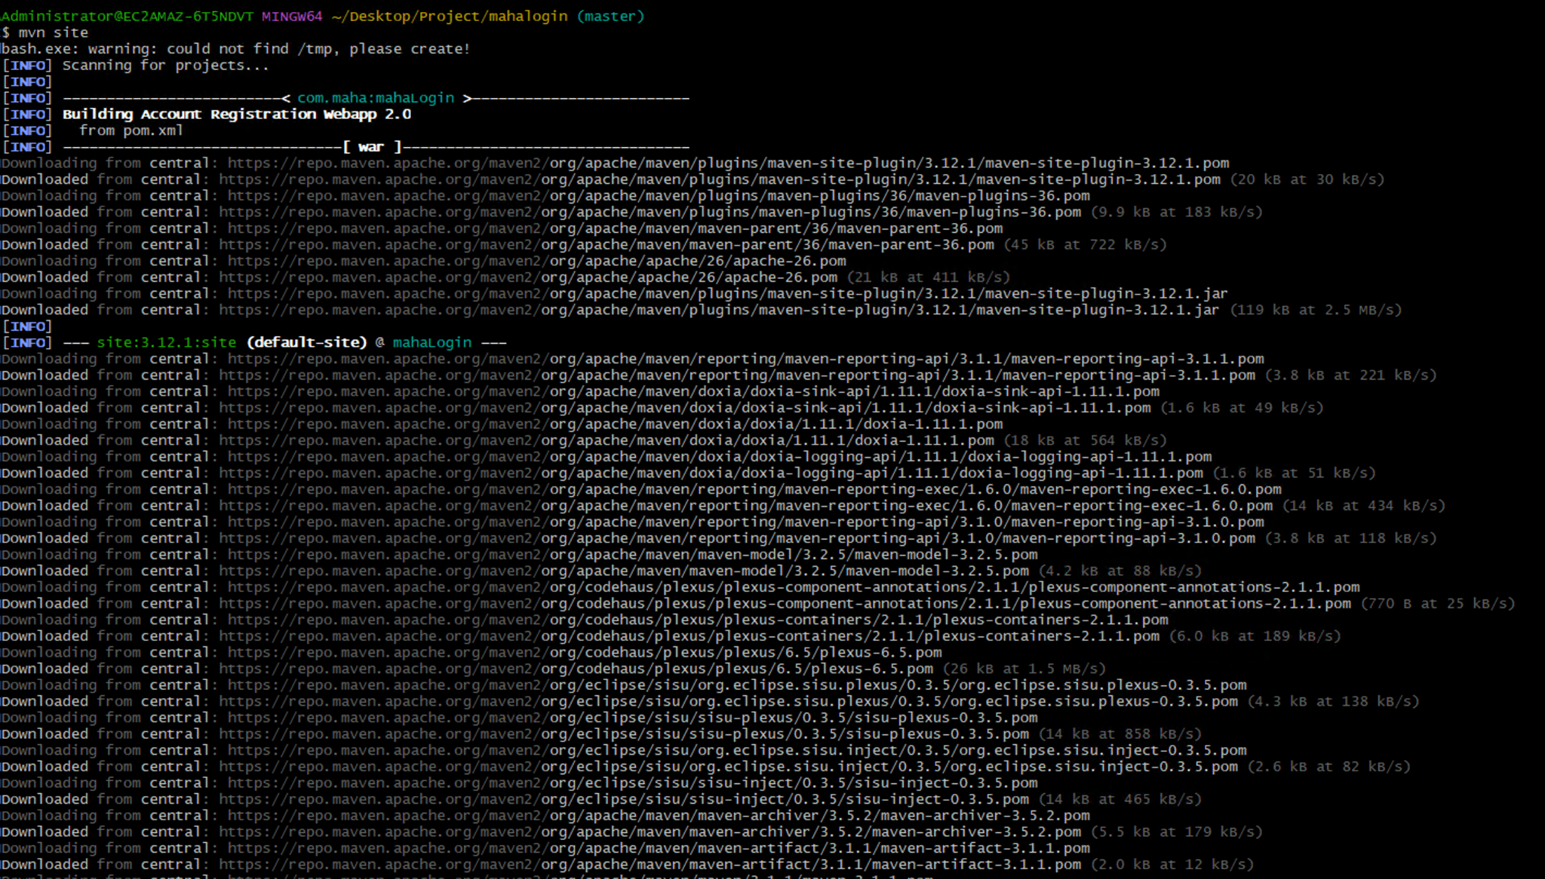

**xcellent — you’ve now run:**

**bash**

**mvn site**

**And Maven is in the process of downloading reporting plugins and generating project documentation.**

## **What mvn site Does:**

**The site phase generates a static website for your project, including:**

| **Report** | **Description** |
| --- | --- |
| **Project Info** | **Basic metadata from pom.xml like name, description, license, developers.** |
| **Dependencies** | **All project dependencies and their scopes.** |
| **Plugins** | **List of plugins used.** |
| **Javadoc** | **Auto-generated JavaDocs for your source code.** |
| **Surefire Reports** | **Unit test results (if any).** |
| **Project Summary** | **Overview of the project.** |

## **Where Is the Output?**

**Once finished, you’ll find a full HTML site in:**

**bash**

**target/site/index.html**

**You can open it in your browser to explore the Maven reports.**

## **What’s Next?**

**Once the download and generation finish:**

**Navigate to:  
  
 bash  
  
target/site/index.html**

1. **Open it in any browser:  
     
    pgsql  
     
   start target/site/index.html**

### **What is a Maven Repository?**

**A Maven repository is a storage location where project dependencies, plugins, and build artifacts are stored and retrieved.**

**It’s used by Maven to:**

* **Download external libraries (like JARs, WARs).**
* **Store your own project outputs (when you use mvn install or mvn deploy).**

### **Types of Maven Repositories**

| **Type** | **Description** | **Examples** |
| --- | --- | --- |
| **Local Repository** | **A folder on your system where Maven caches downloaded artifacts and stores builds you install.** | **~/.m2/repository** |
| **Central Repository** | **Maven’s default public repository. Used if dependency not found locally.** | **https://repo.maven.apache.org/maven2** |
| **Remote Repository** | **An external/internal server (e.g. Nexus, Artifactory) used to share artifacts in teams or enterprises.** | **https://your-nexus.company.com/repo/releases** |
| **Private/Internal Repository** | **Customized repositories for company use — for private builds or restricted environments.** | **Often used in enterprise Maven setups** |

### **Lifecycle Example: When You Run mvn install**

1. **Searches Local Repo (~/.m2/repository)**
2. **If not found, downloads from:**
   * **Maven Central**
   * **or Remote Repos (defined in pom.xml or settings.xml)**
3. **Installs output (.jar/.war) into local repo**
4. **If you run mvn deploy, it uploads to a configured Remote Repo (via distributionManagement)**

### **Configure Repositories in pom.xml**

**xml**

**CopyEdit**

**<repositories>**

**<repository>**

**<id>central</id>**

**<url>https://repo.maven.apache.org/maven2</url>**

**</repository>**

**<repository>**

**<id>my-internal-repo</id>**

**<url>https://repo.company.com/maven2</url>**

**</repository>**

**</repositories>**

### **distributionManagement for Deployment**

**xml**

**CopyEdit**

**<distributionManagement>**

**<repository>**

**<id>releases</id>**

**<url>https://repo.company.com/releases</url>**

**</repository>**

**<snapshotRepository>**

**<id>snapshots</id>**

**<url>https://repo.company.com/snapshots</url>**

**</snapshotRepository>**

**</distributionManagement>**

**Used during mvn deploy to push your build artifacts.**

**Let me know if you want:**

* **Example settings.xml for authentication**
* **Setup for deploying to Nexus or Artifactory**
* **Explanation of snapshot vs release repositories**